A picture containing clipart

Description generated with very high confidence

Azure 103 Module 4

Hands On - 1

Azure Certification Training

[**support@intellipaat.com**](mailto:support@intellipaat.com)

**+91-7022374614**

**US: 1-800-216-8930(Toll Free)**

**Azure 103 Module 4 , Hands On – 1**

**Create a Virtual Network.**

**Step 1:** Open Azure Portal and click on Virtual Networks.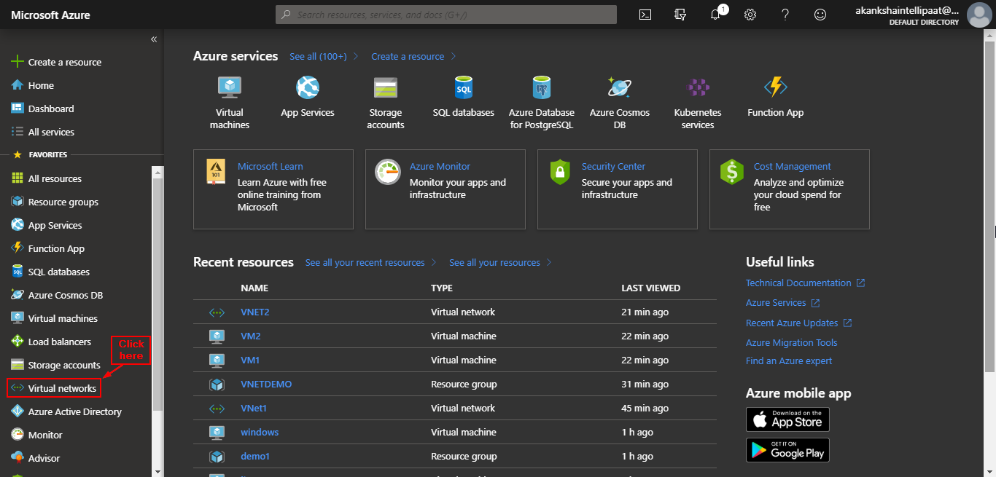

**Step 2:** Click on + Add.

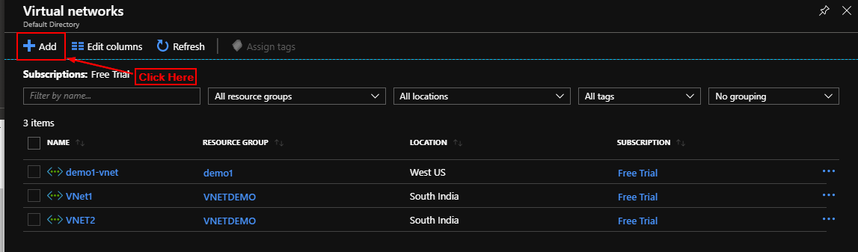

**Step 3:** Enter details and click on create.

